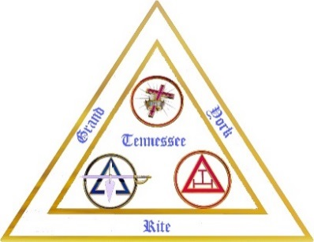
GRAND YORK RITE
TENNESSEE
MEAL ORDER FORM
2026

The following meal tickets can be purchased from the Grand York Rite Office up to March 13th, 2026.
This is a hard deadline the caterer needs time to order his supplies.
SUNDAY
Grand York Rite Banquet – Sunday, March 22nd, 6:00 PM: _______ x $35.00/person = $ ____________

MONDAY
Allied Masonic Degrees Breakfast – Monday, March 23rd, 7:00 AM: _______ x $20.00 /person = $ ____________
Grand York Rite Luncheon – Monday, March 23rd, 12 Noon: _______ x $20.00 /person = $ ____________
Ladies Luncheon – Monday, March 23rd, 11:30 PM: _______ x $40.00 /person = $ ____________
(Ladies Luncheon in the small dining room Grand Lodge Building)
OHP/OST Dinner – Monday, March 23rd, 6:00 PM: _______ x $25.00 /person = $ ____________
TUESDAY
Red Cross of Constantine Breakfast – Tuesday, March 24th, 7:00 AM: _______ x $20.00 /person = $ ____________
(Red Cross Meal is for Members only)
K.Y.C.H. Luncheon – Tuesday, March 24th, 12:00 Noon: _______ x $20.00 /person = $ ____________

Total Enclosed = $ ___________
NOTES:
- If you order meal (s), with the intent to pay at registration/pick up, then do not show, you are still responsible for the costs/payment of those meals you ordered.
- If you order meals and send in the payment, then do not attend, after the meal order has been placed with the caterer, we cannot return your funds.
Name: __________________________________________________________________________________________
Title (to be introduced by): ________________________________________________________________________
Spouse/Friend/Guest’s name: ______________________________________________________________________
Address (Out of State Only): _______________________________________________________________________
PAY BY CHECK ONLY – WE DO NOT ACCEPT CASH
Please make checks payable to: Grand York Bodies of Tennessee
Send Payment to: Grand York Rite Office
100 7th Avenue, North, Suite #3, Nashville, TN 37203-3726
Note: If you wish your tickets mailed to you send a self-stamped return envelope. Otherwise the tickets can be picked up at the York Rite Office. (PAYMENT MUST ACCOMPANY TICKET ORDER)

